NAALAIYA THIRAN

REPORT WEEK 4

Domain: ARTIFICIAL INTELLIGENCE

Project: AI-powered Nutrition Analyzer for Fitness Enthusiasts

Team Leader :SOORAJ K

Team member : RAM BALAJI

Team member :PRASSANA KUMAR

Team member : PRAVEEN RAJ S

Team member : RITHVIK THOTA

2.5. List the ideas (atleast 4 per each team member) by organizing the brainstorming session and prioritize the top 3 ideas based on the feasibility & importance.

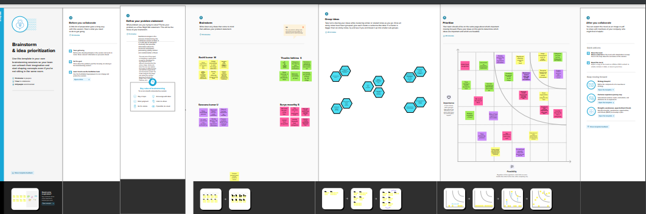

2.6. Attend the technology trainings as per the training calendar.

Attended training as per schedule